San Jose State University

EE250 (Section 2) Fall 2019 Prof. Kamali

Solution to Problem Set #5

- Problem 5.12

- Mapping from to 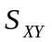

 | 0 | 1 | 2 | 3 | 4 | 5 | 6 | 7
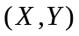 | 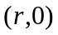 | 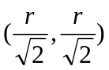 | 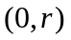 | 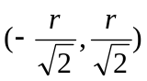 | 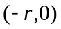 | 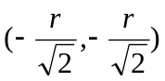 | 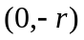 | 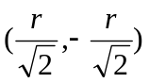

Second row indicates the range of the pair.
b) Joint pmf is shown in the following table.

 | 
 |  |  | 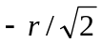 |  | 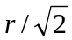
 |  | 0 | 0 | 0.125 | 0 | 0
 |  | 0 | 0.125 | 0 | 0.125 | 0
 |  | 0.125 | 0 | 0 | 0 | 0.125
 |  | 0 | 0.125 | 0 | 0.125 | 0
 |  | 0 | 0 | 0.125 | 0 | 0

c) 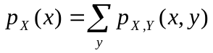, 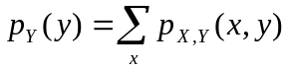

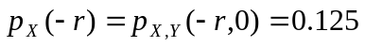
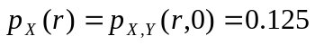

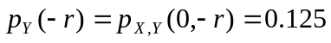
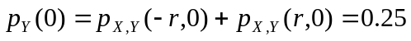
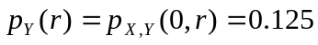

d) 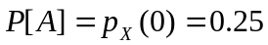
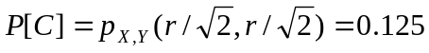
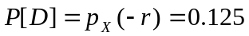

- Problem 5.28
a) 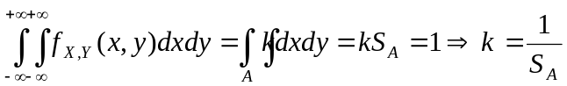

where 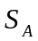is the area of the region over which 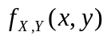is nonzero.

(i) 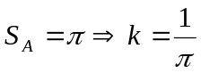
(ii) 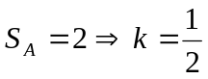
(iii) 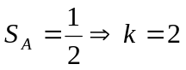

b) 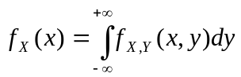
Due to the symmetry in and also in the regions in all cases, 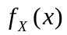and 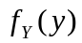are identical.

(i) 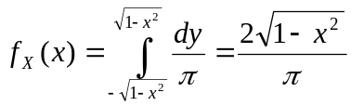 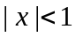
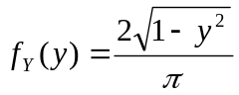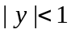

(ii) 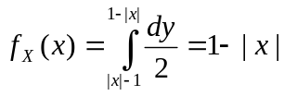

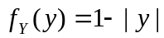

(iii) 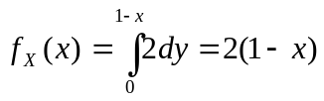 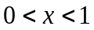
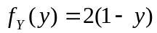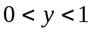

- Since the joint pdf is constant, 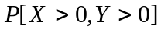is simply the ratio of the area of 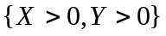to the total area.

(i) 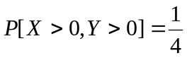
(ii)
(iii) 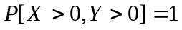

- Problem 5.51
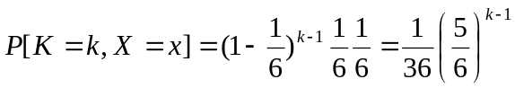 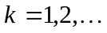, 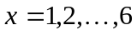
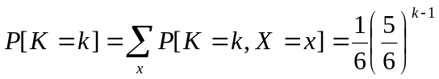
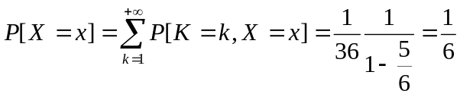
Since , the two random variables and are independent.

- Problem 5.71
a) 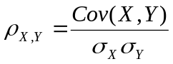

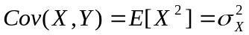

where we have used that and are independent and zero mean.

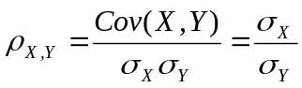

where 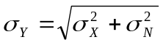again due to the independence of and .

b)

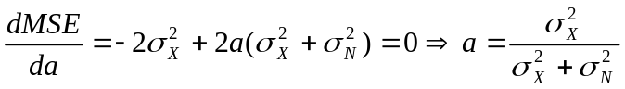

c) 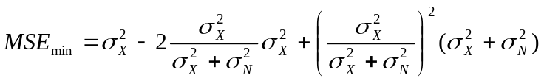

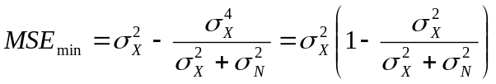

- [Midterm, Summer 2008] Two discrete random variable 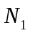and 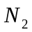have the following joint pmf.

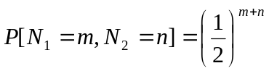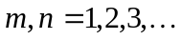

Find the probability 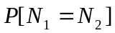.

Solution:
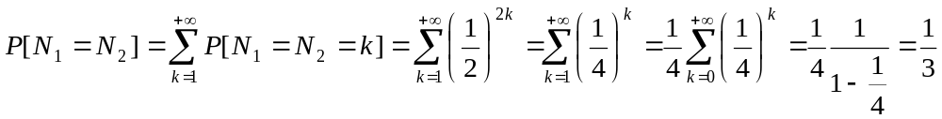

- [Final exam, Spring 2014] The joint pdf of random variables 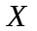 and 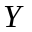is given as follows.

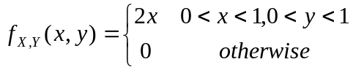

- Find 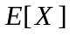.
- Find the marginal pdf 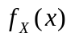 and 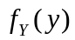.
- Are and independent?

Solution:
- 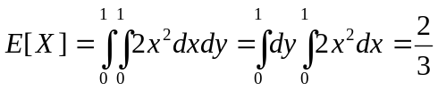
- 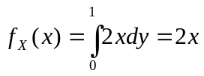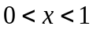

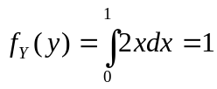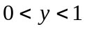

- Yes, since 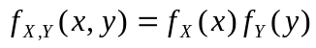, and are independent.

- [Midterm, Spring 2015] The pdf of the random variable is given as follows.

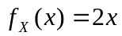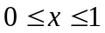

Find the correlation coefficient 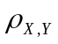between and 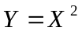.

Solution:

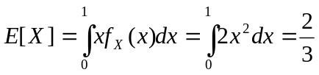
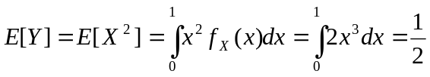
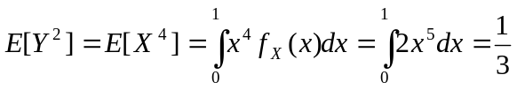
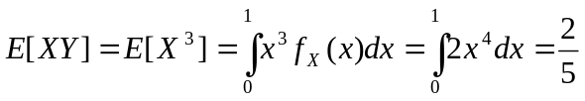
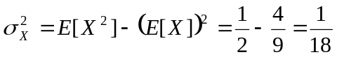
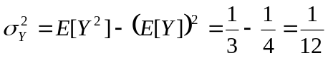

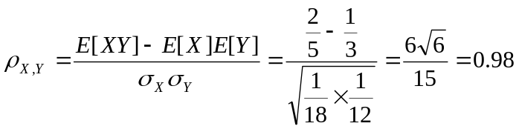

- [Midterm, Fall 2015] The joint pmf of the discrete random pair is given in the following table. Find 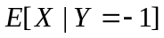.

 | 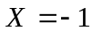 | 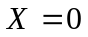 | 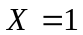
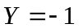 |  | 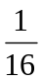
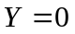 |  | 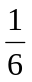
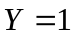

Solution:

We first find the conditional pmf.

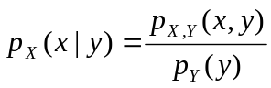

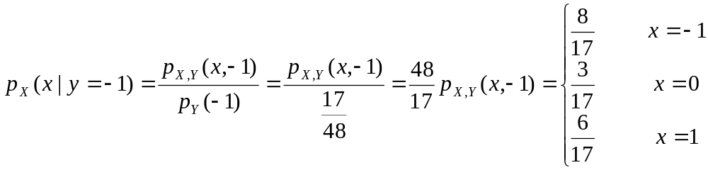

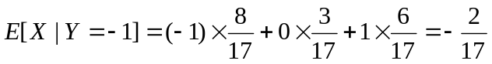

- [Midterm, Fall 2015] The joint pdf of the random pair  is given as follows.

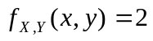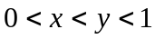

- Find the marginal pdf 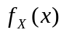 and 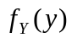.
- Find the covariance of and (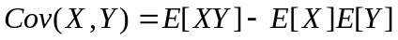).

Solution:

- 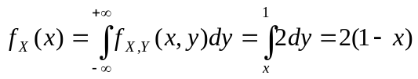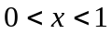
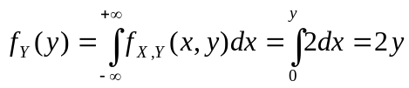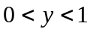

- 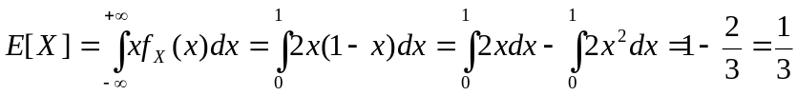

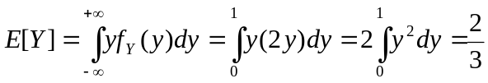

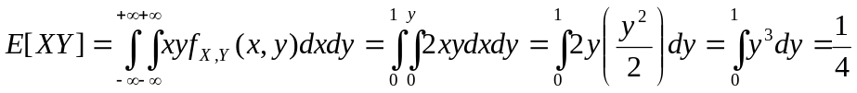

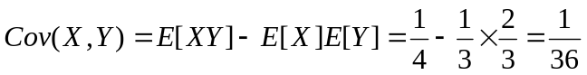

- [Midterm, Spring 2009] Suppose is a zero mean Gaussian random variable and is independent of. Find the correlation coefficient 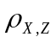 where 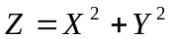.

Solution:
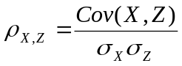

where we have used the independence of and and also 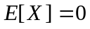. We now note the fact that

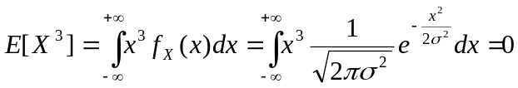

In the above we used the fact that 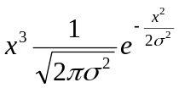is an odd function and so its integral over 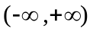is zero. Thus

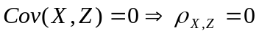

- [Midterm, Fall 2017] The joint pdf of the random pair is given as follows.

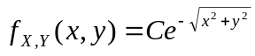 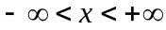, 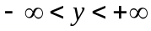

- Find .
- Find the probability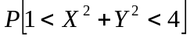.

Solution:
- 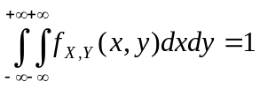

We use polar coordinates to compute the integral as follows.

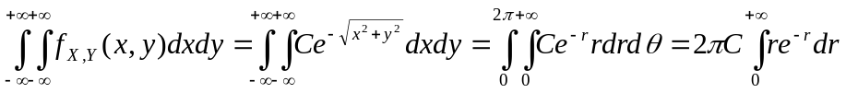
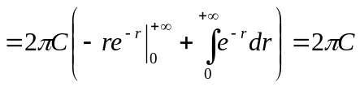

Thus 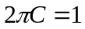and 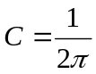.

- 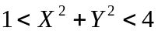 is the area between the two circles with radii 1 and 2 which both have origin as their centers. Again, we use the polar coordinates.

